User’s Guide

Version 5.2k

Last modified: October, 2009

Contents

Introduction 3
Chapter 1 One-click Manager 4
Download and install One-click Manager 4
Managing Files and Folders with Windows Explorer 7
Configure Drive Mapping 7
Logout 8
Help 8
Disconnect AeroDrive 8
Chapter 2 Super One-click Manager 9
Download and install Super One-click Manager 9
How to use Super One-click Manager 9
Chapter 3 Browser Express 10
Logon 10
Explore AeroDrive Internet File Server 11
AeroDrive Function 12
Time Machine 12
Bookmark 15
Transfer Express 17
Managing AeroDrive Internet Drive 21
File and Folder Management 25
Upload, Download and Delete File 27
Chapter 4 Application 33
Application：Teaching and Learning Tools 33
(A) Personal Folder 33
(B) Web Album 33
Web album build up process 34
AeroSkins function 35
(C) Electronic Homework Submission 37
(D) Smart Web Publishing 38
How to view the link of your personal web page 38
Creating you own Web site 38
(E) Electronic File Cabinet 39
(F) My Favourites 39
(G) AeroNotes 42
Application 2：Teaching Resources Sharing 43

Introduction
Thank you for choosing AeroDrive Internet File Server (AeroDrive), this User Manual will introduce you to AeroDrive and help you to get access to AeroDrive right away.

There are three different ways to get access to your AeroDrive. The following will explain step-by-step how to get started using the AeroDrive.

Features of AeroDrive Internet File Server

- Remote access files directly.

- Access files at any time and any places.

- User can upload and download files by using the Windows Explorer.

- User can direct read and write access files in AeroDrive.

- ‘One-click Manager’ and ‘Super one-click Manager’ can process huge amount of files in AeroDrive quickly.

- User can connect to AeroDrive by using ‘Browser Express’ without any program installation.

- AeroDrive allows teachers and students to share teaching materials and learning resources.

- AeroDrive also includes following function:

- Webpage design
- Web Album
- E-submission
- Personal Internet Drive
Every user account contains Personal Internet Drive, it includes
  - ‘public_html’ folder for webpage storage
  - ‘inbox’ folder for homework submission
  - User can create a new folder

This user’s guide will introduce the functions above. User can also refer to the demonstration in ‘technical support’ on AeroDrive website (www.aerocreative.com)

Chapter 1 One-click Manager
One-click Manager provides you a convenient way to connect to AeroDrive. It is most suitable for those users who require login AeroDrive frequently. After installing a download program of One-click Manager, users are able to connect to the AeroDrive and use the Windows Explorer to manage folders or files.

Download and install One-click Manager
Connect to your school AeroDrive Webpage, user can get the link from your AeroDrive administrator.

- Open your school’s home page for AeroDrive.
- Click on the button Download AeroDrive One-click Manager. You may find the button at the top left corner of the AeroDrive Home page.
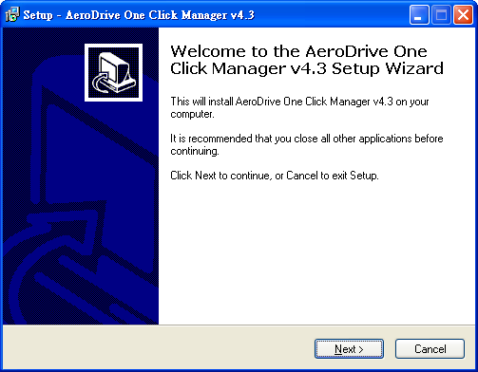
Diagram 1.1 Installation of AeroDrive One-click Manager

- The Install-Shield Wizard will auto-run..
- Choose ‘I accept the agreement’ in License Agreement and click Next.
- Select destination location to save the program.
Click Next to start the Installation procedure.
- When installation completed, click Finish. An AeroDrive icon will be added to your computer Start Menu programs tab.
How to start AeroDrive One-click Manager
If user is using AeroDrive for the first time, please enter required information first.

- Click on the AeroDrive icon on the desktop or click AeroDrive icon in the Start Menu programs tab.
You may find a small AeroDrive icon in your system tray.

- Right-click your mouse on the icon. A menu bar will appear at the bottom right corner.
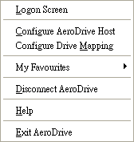
- Choose ‘Configure AeroDrive Host’.
- A dialogue box of AeroDrive Host Configuration will appear.
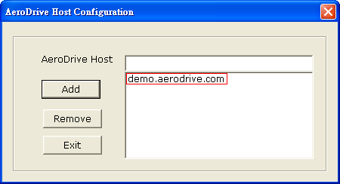
- Enter the IP address or domain name in the AeroDrive Host. Click Add.
- The AeroDrive Host will be added to the window box below. (You may get the IP address or domain name from AeroDrive administrator)
- Click Exit and you may login to AeroDrive now.
Login to AeroDrive
- Double-click on the AeroDrive icon on the desktop or click AeroDrive icon on the Start Menu programs tab. Enter login name and password and click ‘Logon’
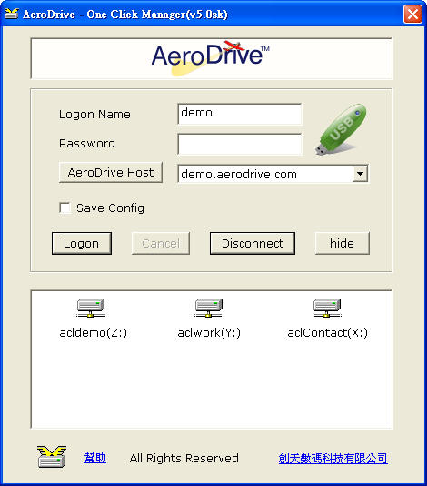
Diagram 1.2 AeroDrive One-click Manager
- You can save logon name by checking Save Config.
- If network drive(s)* appears in the window box, you have connected to AeroDrive successfully.
- Double-click on the icon of any network drive(s). The Windows Explorer will be popup. User may start using the network drive(s) by opening the Windows Explorer directly.
To open the Windows Explorer directly, you may slide the mouse pointer on the Start Menu and right-click it. When a secondary pop-up menu appears, click the Windows Explorer).

Managing Files and Folders with Windows Explorer
You may use all the functions provided by Windows Explorer to move, copy, rename or delete files and folders.

Configure Drive Mapping
User may configure personal AeroDrive, i.e. using Dreamweaver to build a website. AeroDrive allows user to configure by following steps below:
- Click AeroDrive icon in your system tray.
- Right-click your mouse on the icon and a pop-up menu will appear.
- Select ‘Configure Drive Mapping’ and the window blow will appear.
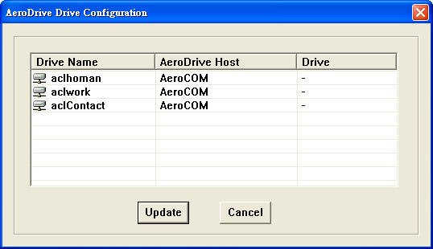
- Configure the drive code in the ‘Drive’ column, then click ‘Update’.
Drive code will be updated when user login next time. User can changed the drive code according to the need.
- Login again to the AeroDrive and changes will apply.

Logout
- Click AeroDrive icon in your system tray.
- Right-click your mouse on the icon and a pop-up menu will appear.
- Choose ‘Exit AeroDrive’ to logout.
Attention: the AeroDrive One-click Manager icon will still remain in system tray and user can login to AeroDrive again.

Diagram 1.3 One-click Manager Menu

Help
If user has any difficulties, please follow these steps:
- Click AeroDrive icon in your system tray.
- Right-click your mouse on the icon and a pop-up menu will appear.
- Choose ‘Help’.
- User will be redirected to our company website.
- User can refer to ‘technical support’ in accordance with different situations.

Disconnect AeroDrive
- Click AeroDrive icon in your system tray.
- Right-click your mouse on the icon and a pop-up menu will appear.
- Choose ‘Exit AeroDrive’ to logout.
- AeroDrive icon in system tray will disappear.

Chapter 2 Super One-click Manager
Super One-click Manager provides you a convenient way to connect to AeroDrive. It is most suitable for those users who frequently logon AeroDrive for remote access. After installing a download program of Super One-click Manager, users are able to connect to the AeroDrive and use the Windows Explorer to manage folders or files.

*Attention: Super One-click Manager only support Windows 2000and Windows XP or above, and the user should be or permitted by AeroDrive administrator.

Download and install Super One-click Manager
Connect to your school AeroDrive Webpage, user can get the link from your AeroDrive administrator.


- Open your school’s home page for AeroDrive.
- Click on the button Download AeroDrive Super One-click Manager. You may find the button at the top left corner of the AeroDrive Home page.
- The Install-Shield Wizard will auto-run.
- Choose ‘I accept the agreement’ in License Agreement and click Next.
- Select destination location to save the program. Click Next to start the Installation procedure.
- When installation completed, click Finish. An AeroDrive icon will be added to your computer Start Menu programs tab.

How to use Super One-click Manager

For the usage of Super One-click Manager, please refer to One-click Manager.

Chapter 3 Browser Express
Browser Express are suitable for user who unable to install ‘One-click Manager’ and ‘Super One-click Manager’. These situations may caused by Firewall setting of the Local Network or other reasons. Instead of managing files by Windows Explorer, Browser Express provides another convenient way to get connected to AeroDrive through Internet Explorer. Besides, other AeroDrive functions such as file sharing or Web Album also need to process through Browser Express.

Logon
- Connect to your school AeroDrive webpage.
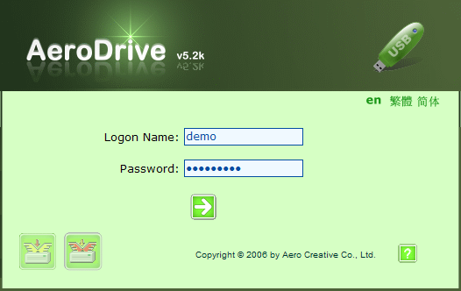
Diagram 3.1 Login to Browser Express

- Enter Logon name and password, and click  to logon. If your account has been configured to logon with USB key, please ensure your USB flash drive has been connected with computer.

Explore AeroDrive Internet File Server
After you have login to AeroDrive, you can access your files and folders in your personal drive.

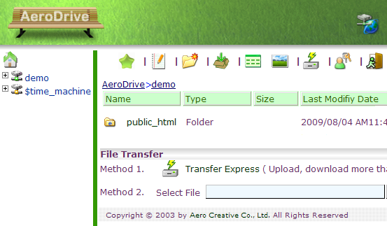
Tool Bar
Navigation Bar

Diagram 3.2 File directories in AeroDrive internet drive

Navigation Bar
You can use Navigation Bar to browse files or folders in different location.

Tool Bar
You can use the tool on Tool Bar to browse the content in AeroDrive Internet Drive or process different functions.

AeroDrive Function

Time Machine
AeroDrive ‘Time Machine’ allows you to explore and download your files and folders on particular date, even if the files or folders had been deleted.
*Function limited to AeroDrive version 5.0 or above only.

Method 1: Access Drive according to Date
  - Open the drive ‘$time_machine’ on Navigation Bar, a list of date will be shown.
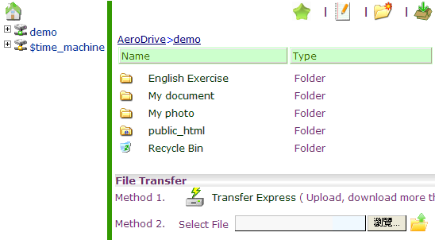
Diagram 3.3 Choosing date to explore in Time Machine
  - A new window will display a file directory of AeroDrive on particular date. User can open or download the file selected.
*The length of time for file storage in Time Machine is customized by AeroDrive Administrator.
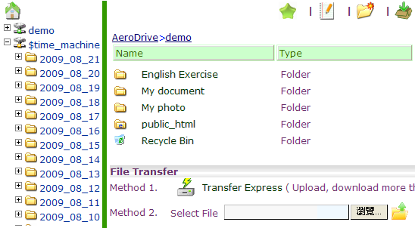
Diagram 3.4 Time Machine showing AeroDrive content on particular date
Method 2: Access Drive according to Target File

    - User can choose particular file and browse amendment within a period of time. Right click on name of the file, select ‘Time Machine version’ on the menu.

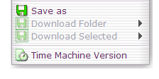
*the name of the file chosen must be the same.

    - The browser will show the file amended on different date. User can either right click on the file name and choose ‘download’, or open the file directly.

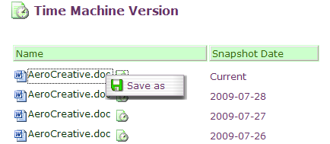

Diagram 3.5 Time Machine showing file amended in different date
Method 3: Access Drive via One Click Manager / Super One Click Manager
User can access time machine version of particular file in AeroDrive via One Click Manager and Super One Click Manager.
- User need to logon One Click Manager and Super One Click Manager.
- Right click on the target file and select ‘Content’ on the menu.
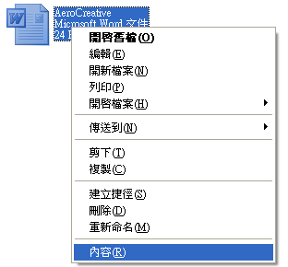
- A window will be pop-up with file description. Click ‘Older Version’.
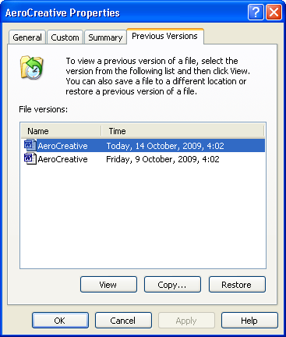
- User can view, copy or restore any file in personal AeroDrive.

Bookmark
User can add bookmark to tag files or folders to access AeroDrive quickly.

- Click ‘Bookmark’ icon on Tool Bar, a small pop-up menu will appear.

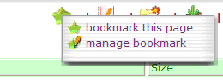
Choosing ‘bookmark this page’, to add bookmark the location they browsing
Choosing ‘manage bookmark’, to rename or delete the bookmark added.
- If you want to add bookmark, click ‘bookmark this page’, a new window will appear.
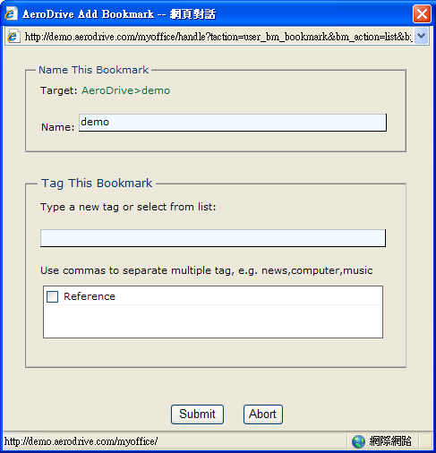
Diagram 3.7 Naming for a new tag
- User can name a new tag and add the bookmark
- Click ‘Submit’ to finish.

- Edit Notes
User can write a note as a reference for file or folder.
- Create Folder
User can create a new folder at the location of file directory.
- Click ‘Create Folder’ icon on Tool Bar, and a small window will appear.
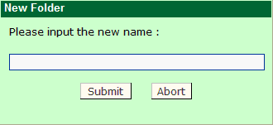
- Input the new name for the folder, and click ‘Submit’ to finish.
- Submission

User can use the ‘Submission’ function to upload files to ‘inbox’ files and transfer files to other users.
(For details, please refer to Chapter 4 – Application 1 – (C))
- Detail View
Change the view to detail view mode. You can view the details of files or folders in this mode. You can sort the files or folders by name, type, size and modified time. Click the description on the column, the files or folders will be sorted automatically.
- Thumbnail
Change the view to thumbnail mode. You can use this function to view the image file that saved as .jpg, .png, .bmp or .gif format.

Transfer Express
‘Transfer Express’ allows user to upload, download or delete files or folders, regardless of the size of files or folders, and user can upload, download and delete more than one file, folder or sub-folder at the same time.

Upload files or folders
- Click ‘ Transfer Express’ on Tool Bar, a new window will appear.
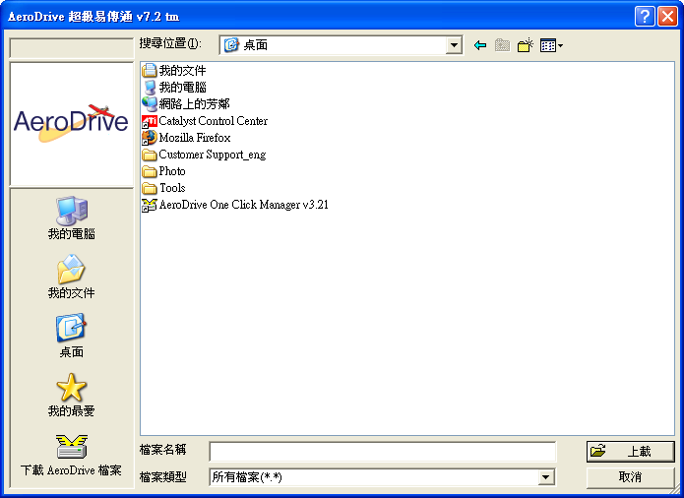
Diagram 3.8 Transfer Express

- Select the file(s) or folder(s), click ‘Upload’.
- AeroDrive Transfer Express will show the upload process. It will be closed automatically after the upload process finished.

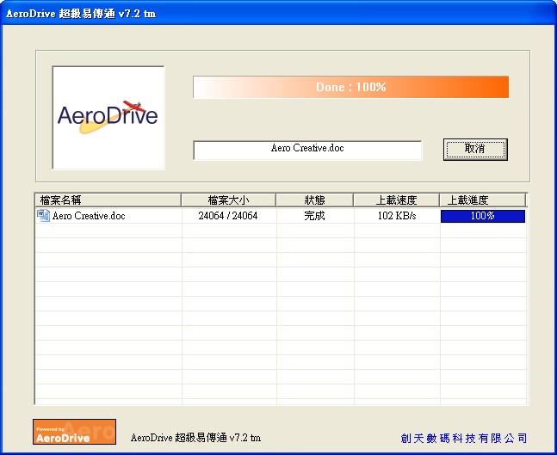
Diagram 3.9 Transfer Express displaying the upload process

Download files or folders
  - Click ‘ Transfer Express ’ on Tool Bar, a new window will appear.
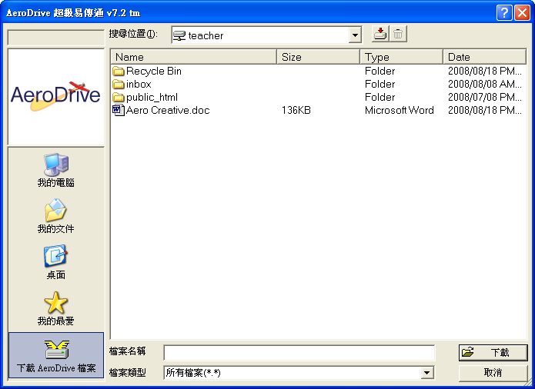
Diagram 3.10 ‘Download AeroDrive Files’ window
  - Click ‘Download AeroDrive Files’.
  - Select the file(s) or folder(s) to download, then click ‘Download’or icon.
  - Choose the location to save file, then click ‘OK’
  - AeroDrive Transfer Express will display the upload process.
It will be closed automatically after finish.

Delete files or folders
- Click ‘Transfer Express’ on Tool Bar, a new window will appear.
- Click ‘Download AeroDrive Files’.
- Select the file(s) or folder(s) to delete, then click Delete icon
- AeroDrive Transfer Express will display the upload process.

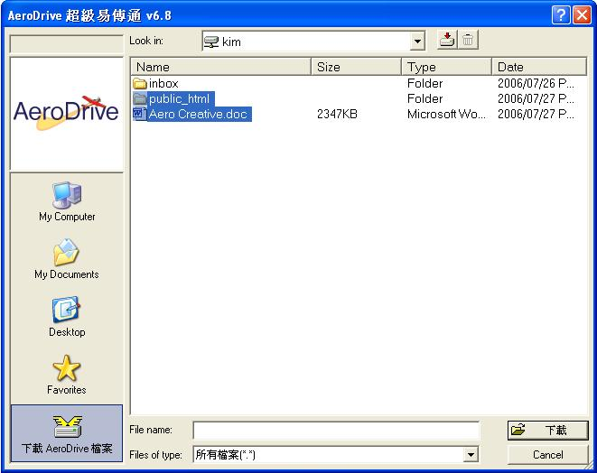
Diagram 3.11 Delete AeroDrive Files window
- User Properties
User can set a new user password by following these steps:
- Click ‘User Properties’ icon on Tool Bar
- Enter the old password.
- Enter the new password.
- Re-enter new password in ‘Password Again’.
- Click ‘Submit’.

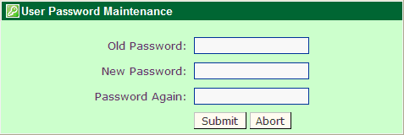
Diagram 3.12 User Password Maintenance

- If user has updated the user password successfully, ‘AeroDrive Success message’ will show the password has been updated.

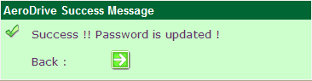
Diagram 3.13 Password updated successful message

- Logout

Click ‘Logout’ icon, browser will turn back to AeroDrive Browser Express logon page.

Managing AeroDrive Internet Drive

After user login to AeroDrive, A list of personal AeroDrive and other Internet Drive will be displayed. User can click into the drive to explore, or process different AeroDrive function by using the right-click menu or the tool bar above.

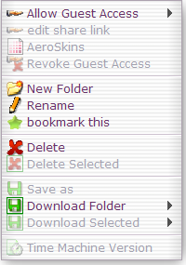
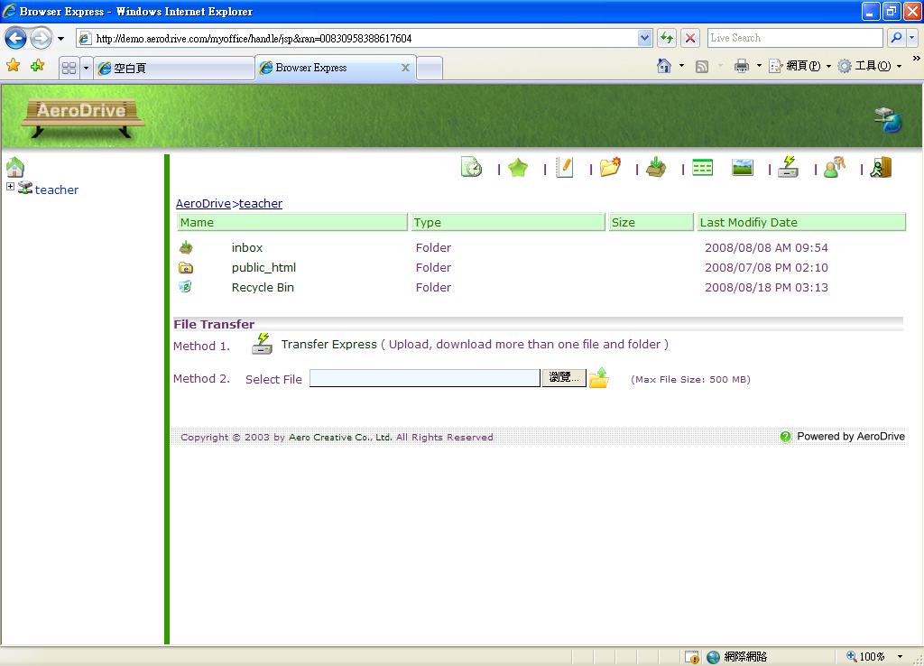
Diagram 3.15
Diagram 3.14 Personal AeroDrive

Click into the personal AeroDrive, user can open or explore files and folders inside. When user clicks the mouse right button on file or folder, a small menu will be pop-up. (Diagram 3.15)

- Allow Guest Access

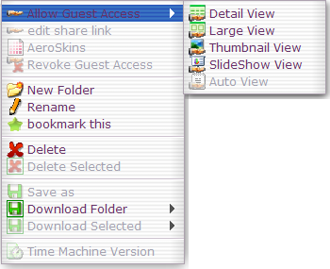
User can share files or folders with other guest by using this function. A new link will be generated after user activated the file or folder as ‘Allow Guest Access’. User can use Cut & Paste method to copy the link and open it on browser.

To share a file or folder, user just needs to right click the mouse button on the file or folder, and select ‘Allow Guest Access’. A sub-menu will appear and user can choose from different view modes. (Diagram 3.16)
Diagram 3.16 ‘Allow Guest Access’ Menu

- Detail view
User can view the details of files or folders in this mode, including name, type, file size and modified time.
- Right click on the file or folder to be shared.
- Select ‘Allow Guest Access ’, and choose ‘ Detail View ’.
- ‘AeroDrive Success Message’ will appear if the file or folder is shared successfully. The file or folder link will be displayed in red color.
- User can cut and paste the link to another browser and open the files or folders.
- Click the button on the right hand side of ‘Copy link to clipboard’ to send the link to others.
- Click the button on the right hand side of ‘Edit AeroSkins’.
Or user can choose ‘ AeroSkins’ on the right click menu to edit AeroSkins.
For the usage of AeroSkins, please refer to Chapter 5 – Application 1 – Web Album – AeroSkins.
- For privacy, user can set password for the file or folder. Enter the password on the space area and click . ‘AeroDrive Success Message’ will appear and show the password set by the user, with a new file or folder link in red color. To explore the file or folder, user has to enter the password to open.
- Click the button on the right hand side of ‘Back’ to go back to the previous level.
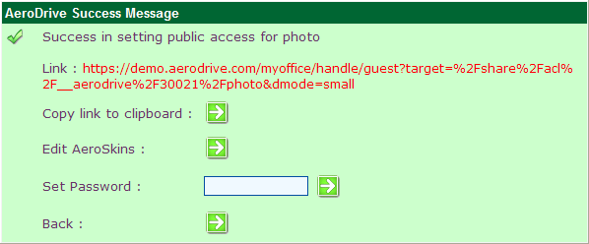
Diagram 3.17 AeroDrive Success Message
- Large View
- Right click on the file or folder to be shared.
- Select ‘Allow Guest Access ’, and choose ‘ Large View ’.
- ‘AeroDrive Success Message’ will appear if the file or folder is shared successfully. The file or folder link will be displayed in red color.
- User can cut and paste the link to another browser and open the files or folders.
- Click the button on the right hand side of ‘Copy link to clipboard’ to send the link to others.
- Click the button on the right hand side of ‘Edit AeroSkins’.
Or user can choose ‘ AeroSkins’ on the right click menu to edit AeroSkins.
For the usage of AeroSkins, please refer to Chapter 5 – Application 1 – Web Album – AeroSkins.
- For privacy, user can set password for the file or folder. Enter the password on the space area and click , ‘AeroDrive Success Message’ will appear and show the password set by the user, with a new file or folder link in red color. To explore the file or folder, user has to enter the password to open.
- Click the button on the right hand side of ‘Back’ to go back to the previous level.

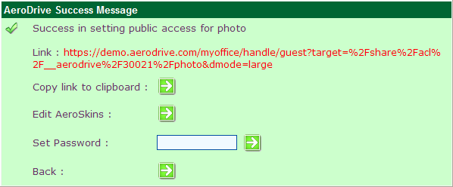
Diagram 3.18 AeroDrive Success Message

- Thumbnail View
User can share files or folders containing image content with others by choosing Thumbnail View. Copy the link generated and open it in a browser, user can save the image file as jpg, png, bmp or gif.

  - Right click on the file or folder to be shared.
  - Select ‘Allow Guest Access ’, and choose ‘ Thumbnail View ’.
  - ‘AeroDrive Success Message’ will appear if the file or folder is shared successfully. The file or folder link will be displayed in red color.
  - User can cut and paste the link to another browser and open the files or folders.
  - Click the button on the right hand side of ‘Back’ to go back to the previous level.

- Slideshows View
User can share files or folders containing video content with others by choosing Thumbnail View. Copy the link and open it in a browser, user can play the video file.

- Right click on the file or folder to be shared.
- Select ‘Allow Guest Access ’, and choose ‘ SlideShow View ’.
- ‘AeroDrive Success Message’ will appear if the file or folder is shared successfully. The file or folder link will be displayed in red color.
- User can cut and paste the link to another browser and open the files or folders.
- Click the button on the right hand side of ‘Back’ to go back to the previous level.

- Auto View
- Right click on the file or folder to be shared.
- Select ‘Allow Guest Access ’, and choose ‘ Auto View ’.
- ‘AeroDrive Success Message’ will appear if the file or folder is shared successfully. The file or folder link will be displayed in red color.
- Click the button on the right hand side of ‘Back’ to go back to the previous level.
- Revoke Guest Access
User can choose ‘Revoke Guest Access’ to disable the guest access of files and folders.

- Right click on the file or folder to be revoked.
- Click ‘ Revoke Guest Access’.
- ‘AeroDrive Success Message’ will appear if the Guest Allowance of the file or folder is disabled successfully.
- Click the button on the right hand side of ‘Back’ to go back to the previous level.
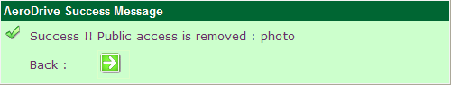
Diagram 3.19 AeroDrive Success Message for ‘Revoke Guest Access’

File and Folder Management
User can manage the files and folders in AeroDrive by using the right click menu. Right click on the file or folder and choose different function.

Diagram 3.20
New Folder
- Right click your mouse button on any file or folder, and a menu will appear.
- Choose ‘New Folder’.
- Input the name for the folder.
- Click ‘Submit’ to confirm and finish.
Open document and file
  - Open the folder and click the file.
  - File Download message will appear.
  - Click ‘Open’ to view the file.

Open Image File
- Open the image file.
- Click Thumbnail icon on tool bar and all image files will be displayed in thumbnail mode.
- Click the file to view. The image will be displayed in another window. (diagram 3.21)
- Click ‘Actual Size’ to view the original size of the image.
- Click ‘Rotate’ to rotate the image viewing.
- Click ‘Slide Show’ to play all image files inside the same folder and user can choose the speed for each slide.
- Click ‘Previous’ to view previous image.
- Click ‘Next’ to view next image.
- Click ‘Close’ to close the window.

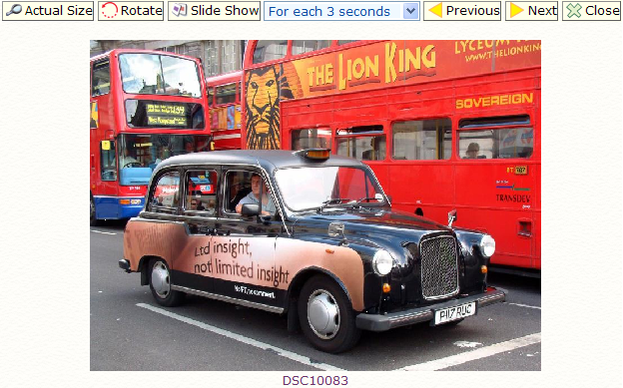
Diagram 3.21 Open Image File

- Rename
User can rename file or folder.
- Right click on the file or folder to be renamed.
- Choose ‘Rename’ on the menu.
- Input the new name for the file or folder.
- Click ‘OK’ to confirm the new Name, or click ‘Abort’ to cancel.
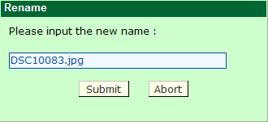
Diagram 3.22 File or folder rename

  - A success message will appear on the top left corner in Browser Express if the file or folder is renamed.

Upload, Download and Delete File
- Upload File
User can upload files in Browser Express by using these two methods:

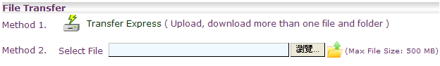
Diagram 3.23 File Transfer

Method 1： Using Transfer Express, user can upload more than one file and folder at the same time, regardless of the size of the file or folder.

- Click Transfer Express icon under File Transfer, or click on the tool bar.
- ‘Aero Drive Transfer Express’ windows will appear:
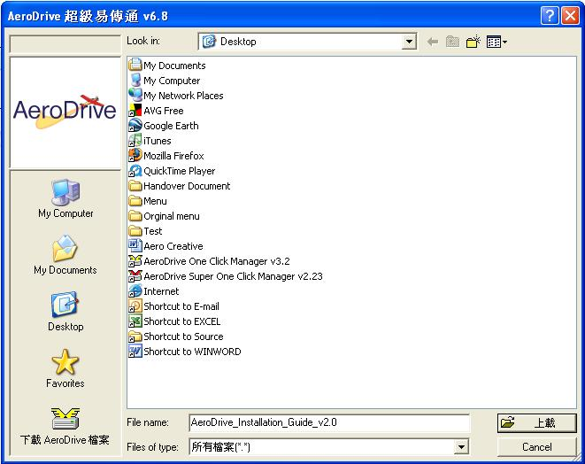
Diagram 3.24 Aero Drive Transfer Express
- User can select more than one file, folder, or sub-folder to upload.
- A new window will appear and show the upload process.
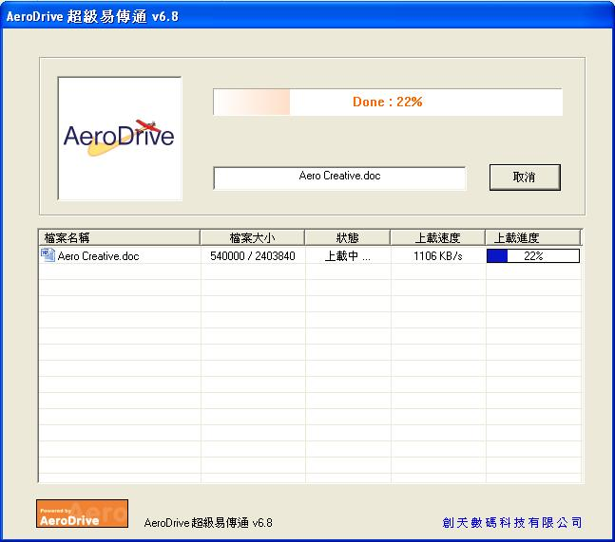
Diagram 3.25 AeroDrive Transfer Express showing the upload process

- The file will be uploaded to the location selected in AeroDrive after the upload process finish.
Method 2︰User can upload file directly without any programme installation. Please notice that it is only suitable for uploading limited size single file.

- Input the file name in the space provided, or Click ‘Browse’ to search.
- Click upload file icon.
- A success message will appear on the top left corner in Browser Express if the file is uploaded successfully.

Diagram 3.26 Uploading single file

- Download File
Method 1：Using Transfer Express, user can to download files and folders.
  - Click Transfer Express icon under File Transfer or choose from tool bar.
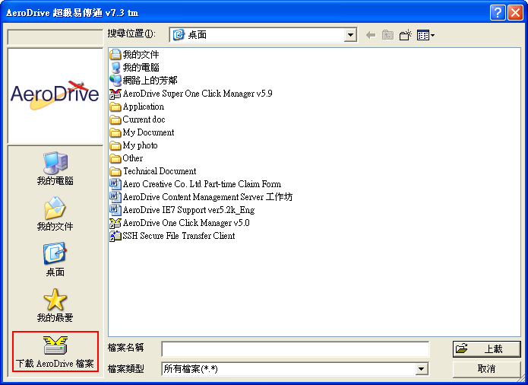
Diagram 3.27 Downloading file from AeroDrive Transfer Express

- Click ‘Download AeroDrive Files’.
- Select files and folders to download, and click ‘Download’.
- Choose the saving location, and click ‘OK’.
- Aero Drive Transfer Express will show the download process. After the download finish, the window will close automatically.
Method 2：User can use right click menu to download files and folders. For single file, user can choose ‘save as’ to download. For folder, user can select either Super Download or Zip Download.

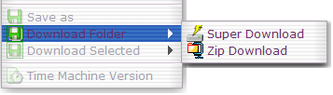
Diagram 3.28 ‘Download Folder’ in right click menu
    - Super download
      - Select Super Download on the menu, choose the save location for file or folder.
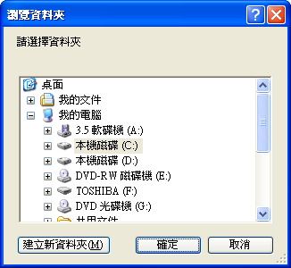
Diagram 3.29 Choose the location to save
      - Click ‘OK’ to confirm. A window will show the download process.
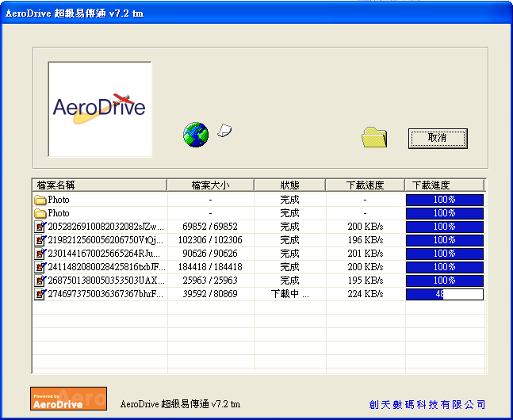
Diagram 3.30 AeroDrive Transfer Express showing the download process
    - Zip download

- Select Zip Download on the menu, and click ‘OK’ to continue.
*File or folder will be converted if file or folder name with non-ASCII charter.

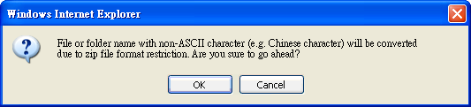
Diagram 3.31 Zip download window

- Click ‘OK’, to start download. Then choose the location to save. 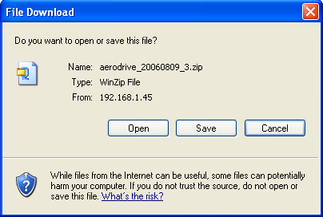
Diagram 3.32 File Download window
Delete File
Method 1：Using Transfer Express, user can to download files and folders.
- Click Transfer Express icon under File Transfer or choose from tool bar.
- Click ‘Download AeroDrive Files.
- Select the deleted files and folder, then click the delete icon on the top right of Transfer Express.
Diagram 3.34 deleting files and folders in Transfer Express

- Aero Drive Transfer Express will show the delete process. After the delete finish, the window will close automatically.

Method 2：User can use right click menu to delete files and folders.
  - Right click the file or folder to be deleted.
  - Click ‘ Delete’.
  - Click ‘OK’ to confirm delete, or click ‘Cancel’ to abort.
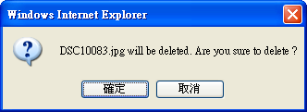
Diagram 3.35 Confirm to delete file or folder

  - AeroDrive Success Message will appear if the file or folder is deleted

Chapter 4 Application

Application：Teaching and Learning Tools

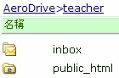
(A) Personal Folder
AeroDrive provide a personal folder in each user account. When user connects AeroDrive through Browser Express, a personal drive will appear. ‘public_html’ will be set in each personal drive and user cannot delete it. User can create a new folder for other purpose.
Create a new folder
Diagram 4.1 Personal Drive


  - Right click your mouse button on any file or folder, and a menu will appear. (Diagram 4.2)
  - Choose ‘New Folder’.
  - Input the name for the folder.
Diagram 4.2 Create a new folder
  - Click ‘Submit’ to confirm and finish.
User can create personal web album within a few minutes. Image files can be displayed as a Web Album, which user can organize and manage all images for different purpose such as teaching. User can share the album with other by configuring the guest access right.

(B) Web Album

- Right click on the folder containing image files.
- A menu will appear, select ‘Allow Guest Access’ and choose ‘ Thumbnail View’.
- ‘AeroDrive Success Message’ will appear and a link will be displayed in red color.
- User can cut and paste the link to another browser and open the link.
- To share the file content with others, copy the link and send it to others.
- To revoke shared file or folder, click ‘Revoke Guest Access’ to disable guest access.
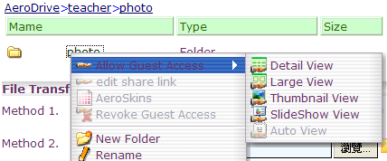

Diagram 3.3Creating Web album by ‘Allow Guest Access’

Web album build up process
User can use AeroSkins to edit your Web Album design. You can customize the color, header and thumbnail, to suit your design.

- After you click ‘Thumbnail View’, AeroDrive Success Message will appear: 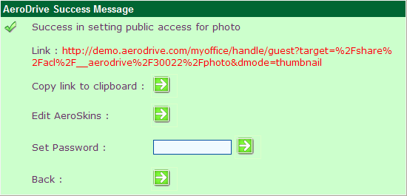
Diagram 4.4 Public Access Setting

- If you want to edit your album, click button on the right hand side of ‘Edit AeroSkins’.
- Click AeroSkins and edit the album.
- User can also back to Browser Express, and use the right click menu to edit AeroSkins.

- Right click the shared folder name

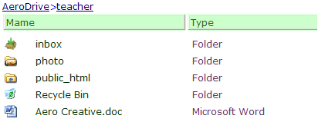

(ii) Click ‘ AeroSkins’
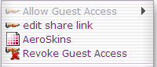

AeroSkins function

1. Color
Choose the color for Background, Header, Text or Link from the color pad.
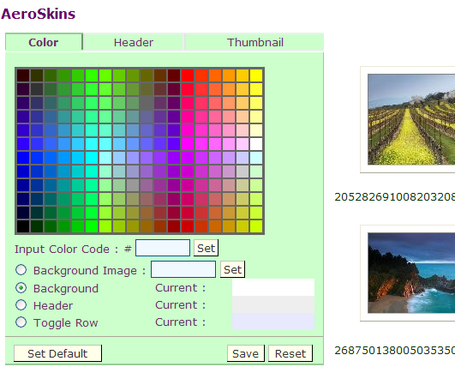

2. Header
Edit your header by entering text, insert image or media etc.
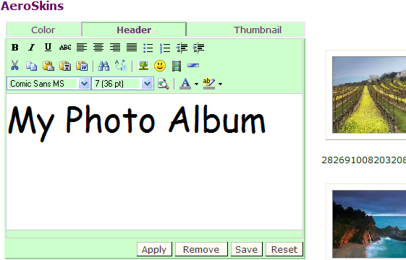

3. Thumbnail
Edit the size of thumbnail, image per row and page.
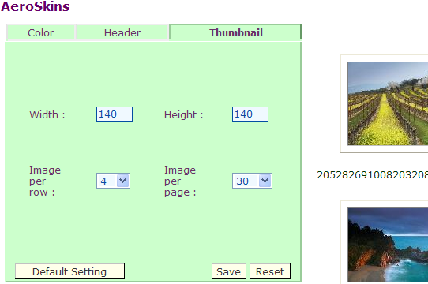

After you have finished, click ‘Save’ to save the change.
AeroDrive Success Message will appear (diagram 4.5) and you can click button next to ‘Preview’ to preview you album.
If you want to edit AeroSkins, click button next to ‘Edit AeroSkins’ to continue.

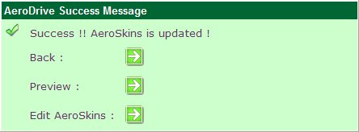
Diagram 4.5 AeroDrive Success Message for AeroSkins Update
Electronic Homework Submission (EHS) is specially designed for school teachers to collect student electronic homework. Teachers can now collect electronic homework via Internet instead of collecting floppy disks, CD-Rom or receiving E-mail attachment from students. By using EHS, teachers can save their invaluable time and it is environmental friendly as fewer papers, floppy disks and CD-Rom are consumed.

(C) Electronic Homework Submission

For Teachers
- Connect to AeroDrive by using any one of three Connection Methods.
- Click ‘ Inbox’ folder shown in Browser Express.
- Create a folder for collecting homework. Students can now upload their homework.
- Teachers can choose different group to view homework submitted by students.
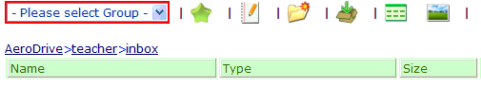

- Teacher can view the homework by students, submission date, time and size of file. Name of the student will be put at the beginning of the file name.
- After the deadline, teacher can collect all the electronic homework in the folder.

For Students
- Connect to AeroDrive by using any one of three Connection Methods.
- Click Submission icon on tool bar.
- Click homework folder created by teacher.
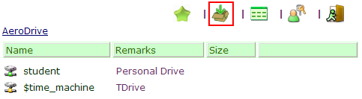
- Select homework, then click Upload icon to submit.
- AeroDrive Success Message will appear if the homework is uploaded. Students can view their submission date, time and size of the file.
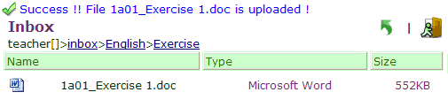
For users who need to update their home page frequently, AeroDrive provides a quick way to create their own web pages. By using Smart Web Publishing, users can use AeroDrive instead of FTP client software to download or upload their web pages. A default folder named ‘public_html’ in AeroDrive is designed for the purpose of web pages storage. By simply drag-and-drop method, users can directly make changes of their web pages ‘public_html’ folder.

(D) Smart Web Publishing

    - How to view the link of your personal web page
- Use One-Click Manager or Web Connection Manager to connect to AeroDrive.
- Open the folder public_html in your personal drive. A sample webpage has been already published in the folder.
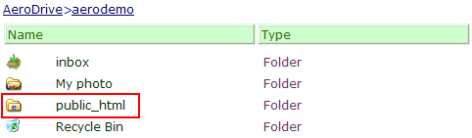

- For public access, the link is a combination of the domain name or IP address and the user’s login name. For example, if the domain name is company.user.com and the login name is paul, the link shall be http://company.user.com/~paul/
- Do not forget to type the 「~」after the IP address or domain name.
- Please note that the web page can be opened by other only if the ‘public_html’ folder is shared in AeroDrive.

    - Creating you own Web site
You can create your own Web site by drag and drop method. You can directly copy all your Web pages to the folder public_html. To view the updated web pages, simply open the link on Internet Explorer and click Refresh to view.
Electronic File Cabinet allows users to share their files with others Users may share files, folders or drives by using ‘Allow Guest Access’ function.

(E) Electronic File Cabinet

- Connect to AeroDrive via Browser Express.
- Slide the mouse pointer on the drive, folder or file you want to share with students.
- Clicks ‘Allow Guest Access’ and choose the view mode.
- ‘AeroDrive Success Message’ will appear and a link will be displayed in red color.
- User can cut and paste the link and share with others.
- User can edit AeroSkins for shared files. Please refer to Application 1 – (B) Web Album – AeroSkins Function.

(F) My Favourites
My Favourites allows user to store shortcuts in ‘My Favourites’ for frequent visit or back-up. Users may copy the shortcuts from client computer to AeroDrive Favorites Folder or vice versa. User can open the shortcuts in AeroDrive Favorites Folder from anytime, anywhere via any computers with internet access.
- Click on the AeroDrive icon on the desktop or on the Start menu
- Right Click AeroDrive icon in the system tray.
- A menu will be pop-up, choose ‘My Favourites’.

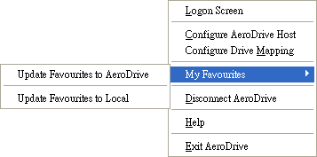

Diagram 4.6 ‘Update Favourites to AeroDrive’ and ‘Update Favourites to Local’ menu.
- User will find two options:
  - Update to AeroDrive Favourites
  - Update to Local Favourites

- Update to AeroDrive Favourites
  - Choose ‘Update to AeroDrive Favourites’, a windows will be pop-up and show the updating process.
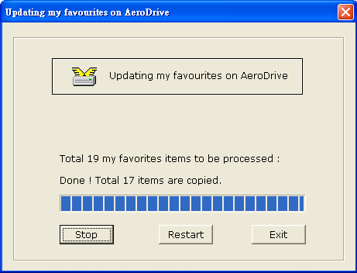
Diagram 4.7 Updating my favourites on AeroDrive

  - User can click ‘Stop’ to stop the update, ‘Restart’ to restart the update.
  - Click ‘Exit’ to leave after the update finish.
  - Connect to AeroDrive via Browser Express. If it is the first time to update Favourite to AeroDrive, A folder named ‘Favourites’ will be created.
  - All Favourites will be copied to ‘Favourite’ in AeroDrive.
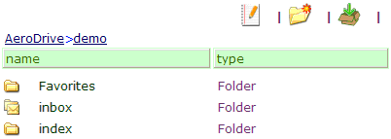
Diagram 4.8 ‘Favourites’ in Personal AeroDrive

- Update to Local Favorites
  - Choose ‘Update to Local Favourites’, a window will show the update process.
  - User can click ‘Stop’ to stop the update, ‘Restart’ to restart the update.
  - Click ‘Exit’ to leave after the update finish.

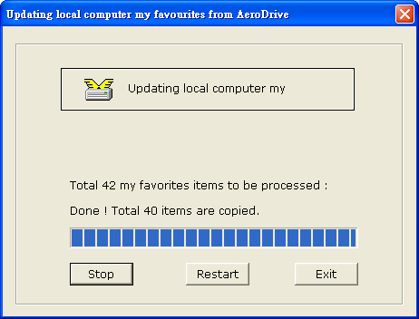
Diagram 4.9 Updating local computer my favourites from AeroDrive

*The Update is an overwrite function. For example, if users click Update to AeroDrive Favorites, all the original shortcuts in Favorites folder in AeroDrive will be replaced by shortcuts in the Favorites folder of local computer. Users are reminded to perform the Update with care.

(G) AeroNotes
Administrator can configure which user accounts can edit system notes in AeroDrive logon via Browser Express. When these accounts input any system note, all accounts will receive the note after connecting to AeroDrive on Browser Express. For ‘share all’ type AeroDrive, user can edit AeroNotes for the folder.

  - Click AeroNotes icon on tool bar.
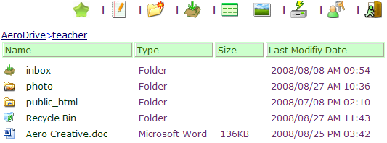

  - Input content for the note.
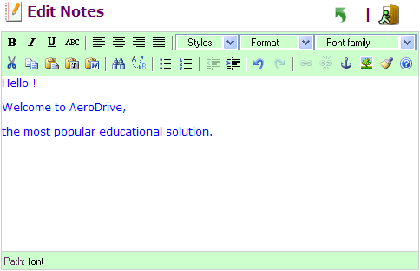
  - Click ‘Save’ to finish.
  - User will see the note when logon to AeroDrive.
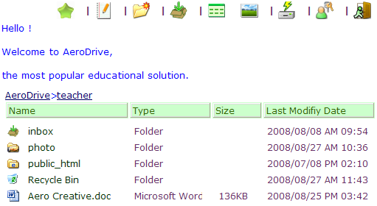

Application 2：Teaching Resources Sharing

The resources sharing feature of AeroDrive encourage users to share teaching resources or learning materials with others. AeroDrive Administrator can customize the personal AeroDrive for each user in accordance to different needs.

For information and cases studies on internet drive file sharing, please visit to our company website at www.aerocreative.com .

* * * End * * *

