AeroDrive Internet File Server
Quick Start Guide v5.2k
(2009-Aug)

There are three ways to access files in Personal AeroDrive:
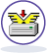
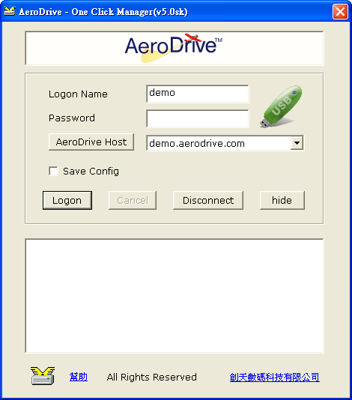

1. One Click Manager
One Click Manager provides you the fastest way to access file inside Personal AeroDrive. You can download and install One Click Manager on the AeroDrive Web logon page.

Please note that One Click Manager is meant to be used in local LAN environment. For remote access, please use “Super One Click Manager”.

「One Click Manager」Usage:
1. Configuration
Please input Personal AeroDrive Host IP address for first time use. Open one click manager logon window and click “AeroDrive Host” button. Input your AeroDrive domain name or IP (given by AeroDrive Administrator), then click “Add”. Click “Exit” to finish configuration.

2. Logon and Logout
- Open One Click Manager and input your Logon Name and Password. If your account has been configured as logon with USB key, please ensure your USB flash drive has been connected with computer.
- Upon successful logon, you will see network drives appeared in the space below. Double click on your network drive and a new window explorer will be pop-up.
- You can explore your content in your personal AeroDrive now.
- To logout Personal AeroDrive, click the “Disconnect” button.
- To quit One Click Manager, left click your mouse button on “One Click Manager” icon in system tray. Choose “Exit AeroDrive” to quit.

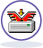
2. Super One Click Manager

Super One Click Manager enables you to map virtual drive on Personal AeroDrive over internet with data encryption supporting Windows 2000/Windows XP/Windows Vista / Windows 7 or above platform and requiring user account with windows administration privilege.

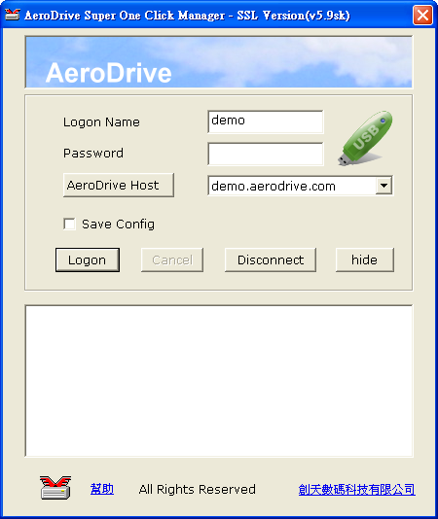

For usage of Super One Click Manager, please refer to “One Click Manager”.


3. Browser Express (Web Access)

Browser Express is the web access interface of Personal AeroDrive. There is no requirement for program installation to access the files on internet at anywhere and anytime.

To access the Browser Express, users need to logon to Personal AeroDrive through Internet Explorer.

- Open Internet Explorer to AeroDrive webpage, input your username and password, then press “” button to connect. If your account has been configured to logon with USB key, please ensure your USB flash drive has been connected with computer.

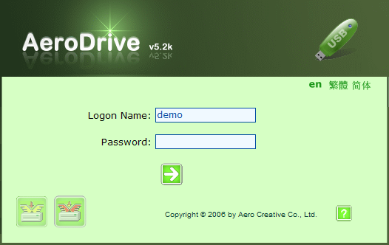

- Upon successful logon, you will see the following screen.

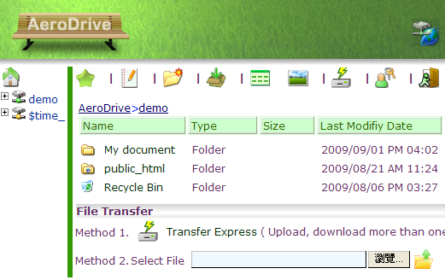

On the left you will see the tree view of Personal AeroDrive while the full view of the drive is on the right. There is menu bar on the top right hand corner and the items represent different function:
Item | Name | Description
 | Home | Back to Homepage
 | Bookmark | Bookmark to access web pages or files directly
 | Edit Notes | Drop notes to every folder for reference
 | Create Folder | Create a new folder
 | Submission | Navigate to each user inbox to upload file
 | Detail View | Detail view with small icon, type , size, modification time
 | Thumbnail | View the file in thumbnail view
 | Transfer Express | Upload or download more than one file and folder (ActiveX control installation may be required)
 | User Properties | Change user password
 | Logout | Logout the application

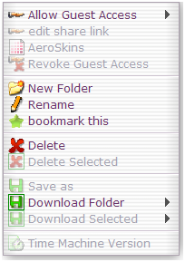
Basic Usage of Browser Express
a) Create new folder
- navigate to your virtual drive.
- Right click your mouse and select “New Folder” from menu.
- Input folder name and press “OK”.

b) Rename or Delete file or folder
- Select target folder or file.
- Right click your mouse and select “Rename” or “Delete” from menu.
- For “Rename”, input new name for the file or folder.
- For “Delete”, press “OK” to delete the file or folder.

c) Sharing your files or folder over internet
- Select target folder or file.
- Right click your mouse and select “Allow Guest Access” from menu.
- Select “Allow Guest Access” as Detail view, Large view, Thumbnail view, SlideShow or Auto view from the sub menu.
- A URL will be displayed to share your file or folder.

d) Upload file
There are two methods to upload file on Browser Express:
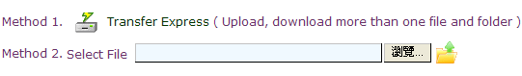

Method 1: Use Transfer Express for batch uploads files and folder. For first time use please download a program attached from the webpage directed. After installation, you can upload more than one file or folder at a time.
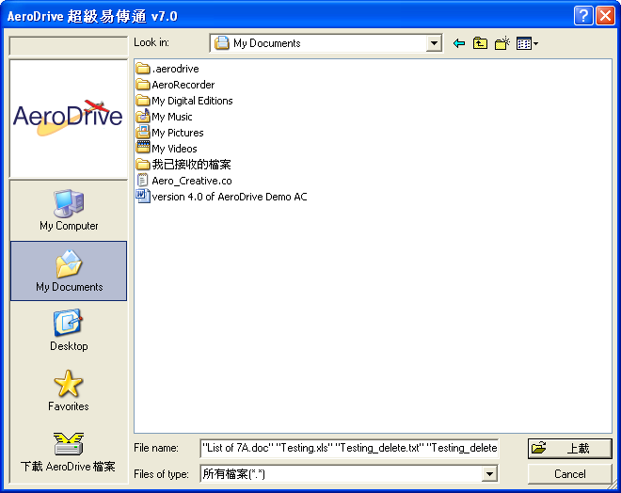
Method 2: you may upload a file one by one.

e) Download file
There are two ways to upload file:

Method 1: Download files and folder via Transfer Express. For first time use please download a program attached from the webpage directed. After installation, you can upload more than one file at a time.

Method 2: By using right click menu, user select “save as” or “download folder” to download file.
For “save as”, user can download one single file directly.
For “download folder”, user can select either “Super Download” or “Zip Download” to download file or folder.

*The quick start guide only includes Logon and basic usage of AeroDrive. For further details, please refer to AeroDrive User Guide, which is available from our website: http://www.aerocreative.com/help
*END*

