AeroDrive Internet File Server
Quick Start Guide v3.1
(2006-Jul-26)

There are three ways to access file inside Personal AeroDrive :
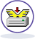

1. One Click Manager
One Click Manager provides you the fastest way to access file inside Personal AeroDrive.

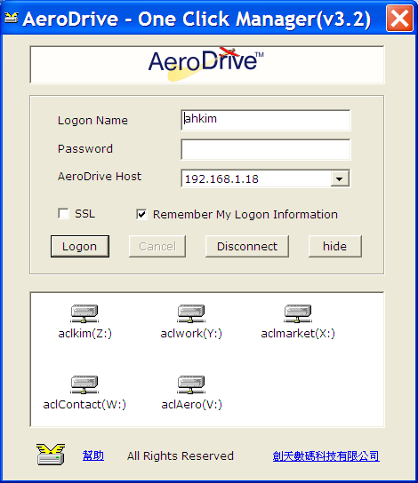
Just download and install One Click Manager on the Web logon page of your Personal AeroDrive.

Please note that One Click Manager is meant to be used in local Lan environment as there is no data encryption mechanism.

For remote access, please use “Super One Click Manager”.

「One Click Manager」Usage:
1. Configuration
Please input Personal AeroDrive IP address for first time use. To change AeroDrive Host IP, please right click your mouse upon point “one click manager” icon in your windows system tray area (normally at the bottom right corner). After seeing the popup menu, select “Configure AeroDrive Host” and change the IP inside.

2. Logon and Logout
- Execute One Click Manager (should be in the desktop or program menu) and input your username and password
- Upon successful logon, you will see some network drive inside the small windows.
- Double click any network drive will bring you a new windows explorer and you can start using Personal AeroDrive
- To logout Personal AeroDrive, just press the “Disconnect” button and all the drives will be disconnected.
- To quit One Click Manager, bring up “Personal AeroDrive Popup Menu” by right click the One Click Manager icon in the system tray area and select “Exit”

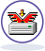

2. Super One Click Manager

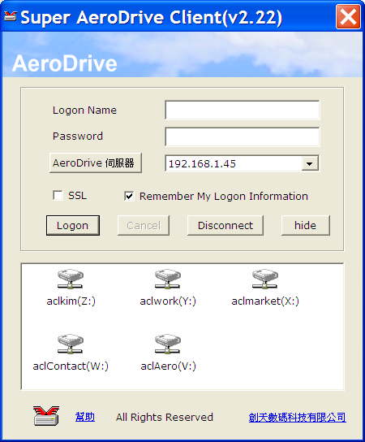

Super One Click Manager enables you to map virtual drive on Personal AeroDrive over internet with data encryption. However, there are some limitations:

- support only W2K/XP or above
- require windows administration privileges user account

Usage of Super One Click Manager is similar to One Click Manager


3. Browser Express (Web Access)

Browser Express is the web access interface of Personal AeroDrive. There is no need for program installation and can be accessed across internet anywhere anytime. Just point your IE at your Personal AeroDrive, sometimes your URL must come with a port : 8899 in case of ISP blocking of port 80, and input your username and password and press “Connect”.

(* Please note that some features may not supported in browser other than IE 6.0 or above)

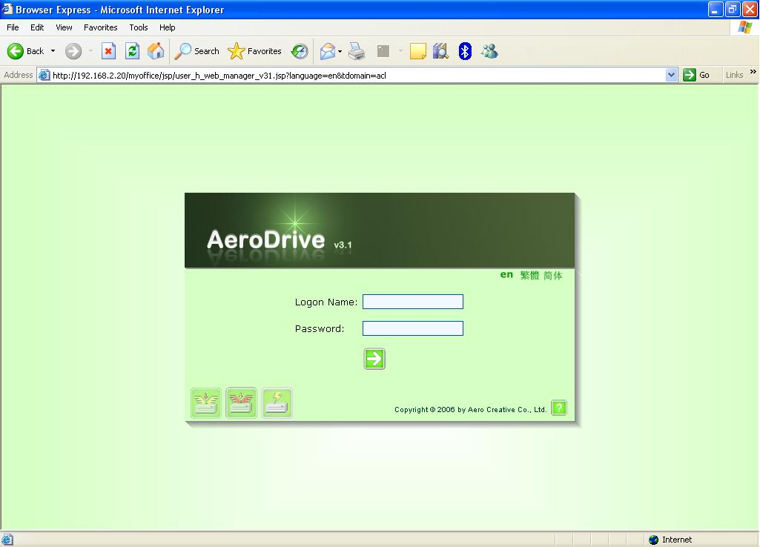

Upon successful logon, you will see the following screen.

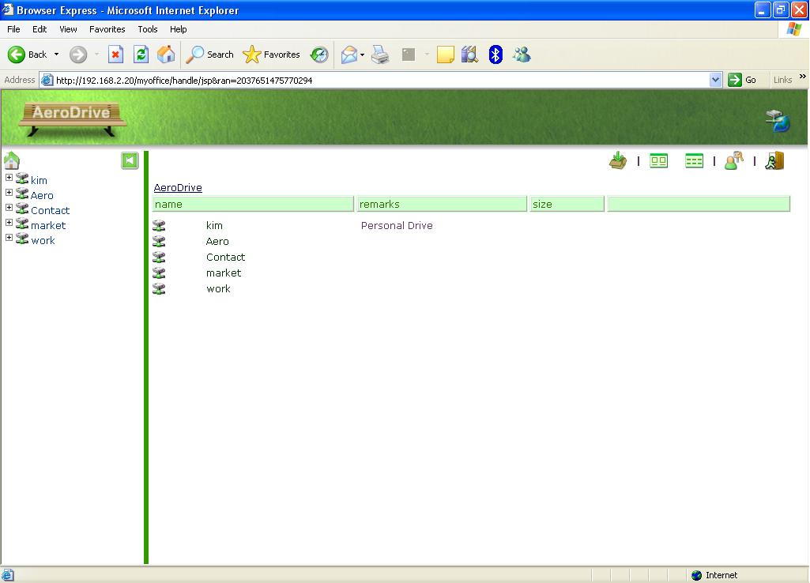

On the left is the tree view of Personal Aero while there is a full view of on the right. You may see more than one virtual drive as this depends on how your Personal AeroDrive admin configure your server.

Normally you will see a virtual drive with the same name as your logon name and this is your personal drive. And there is a public_html directory inside your home drive and please be reminded that all your files stored under public_html can be accessed by anyone over internet without any authentication and this directory serves as your personal web page with the URL as
“http://YOUR_AERODRIVE/~YOUR_LOGON_NAME’’

There is menu bar on the top of the right frame and here are the explanations :

Item | Name | Description
 | Homepage | Back to Homepage
 | Tree View | Toggle tree view
 | AeroDrive Note | Drop notes to every folder and serves as a “Read me”
 | Submission | Navigate to each user inbox to upload file
 | Large View | Large view with only large icon and file name
 | Detail View | Detail view with small icon, type , size, modification time
 | Thumbnail View | View the file in thumbnail view
 | Super Express | Enable batch upload and download of files ( a ActiveX control and need installation)
 | Change Password | Change user password
 | Logout | Logout the application

General Usage of Browser Express
( * right click menu not support in firefox or opera)
a) Create new folder
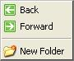
- navigate to your virtual drive
- Right click your mouse at any space and a small popup menu will display
- Select ‘New Folder’
- Input new folder name and press “OK”

b) Rename or Delete file or folder
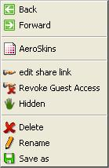
- Point your mouse at the folder or file
- Right click your mouse and a small popup menu will display
- Select ‘Rename” or “Delete”
- Input new name for “Rename” or press “OK” to delete

c) Sharing your files or folder over internet
- Point your mouse at the folder or file
- Right click your mouse and a small popup menu will display
- Select ‘Allow Public Access” or “Allow Public Access As Thumbnail”
- A URL will be displayed and please copy and paste and send to your friends
- Sometimes you have to add a port 8899 at the URL to enable internet access in case your ISP block your HTTP traffic , i.e your URL will be something like this
http://PERSONAL_AERODRIVE_HOST:8899/xxxxx/xxx/xxx .....

d) To upload or download file

There are two ways to do this

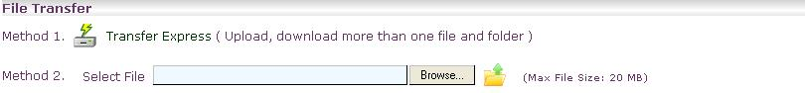

Method 1: Use Transfer Express for batch upload and download files & folder. First time user will be prompted to download a program. After installation, you can upload more than one file at a time

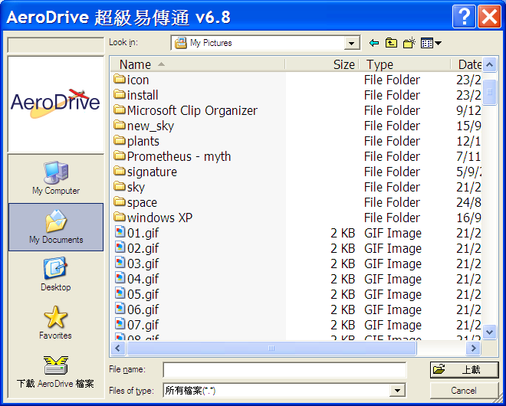

Method 2: you may upload a file one by one.

*END*

